

Computer Vision

Section-1

Submitted to faculty: Professor Mehul Raval

Date of Submission: 13-04-2022

Student Details

Computer Vision-Super Image Resolution

| Roll No. | Name of the Student | Name of the Program |
| --- | --- | --- |
| AU1940109 | Jap Purohit | CV |
| AU1940034 | Varun Deliwala | CV |
| AU1940267 | Sahil Miskeen | CV |
| AU1940142 | Shail Patel | CV |

**Tasks performed this week:**

The problem with using transpose convolutions was the checkerboard artifacts. In order to solve the checkerboard artifacts we used a more sophisticated and finer method known as pixel shuffler. It involved feature level extrapolation so it led to better results. The architecture and the results are attached below.

**Outcomes:**

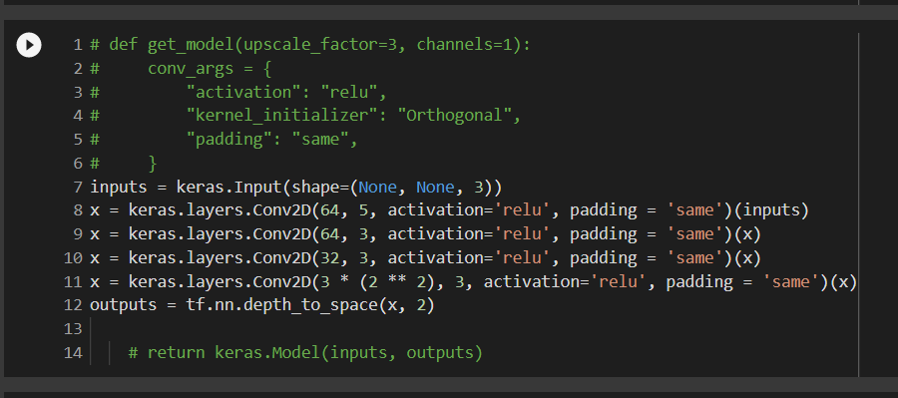

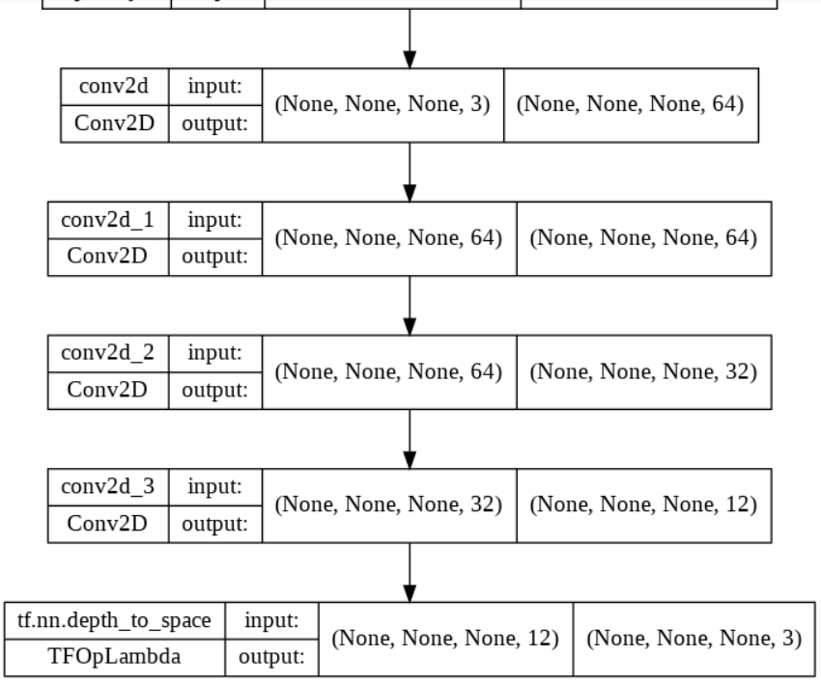

The output of the image is shown below

**Low Resolution Image (100 * 100 * 3)**

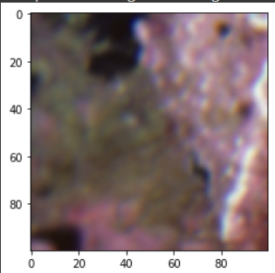

**High Resolution Image Model Predicted (200 * 200 * 3)**

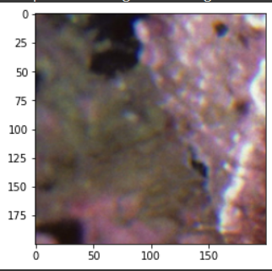

**The model is able to scale the low resolution image by a factor of 2 which has been specified by us while training the model.**

**As visible the output is much better than the one achieved by transpose convolution.**

**Tasks to be performed next week:**

Implement GAN models and see if we can make the process dynamic as in get the input from the user to which factor does he want to scale the image to.